# **Name: Abdurrahman Qureshi**

# **Roll No: 210451**

Practical No: 11

1. **Adding an image at Run Time**

**CODE:**

Public Class Form1

Dim runImg As New PictureBox()

Private Sub Form1_Load(sender As Object, e As EventArgs) Handles MyBase.Load

runImg.Location = New Point(40, 0)

runImg.Size = New Size(1450, 788)

runImg.Image = Image.FromFile("I:\Gold Roger\SEM 4\GAD\Manual Apps\EXP11PicBox\HFW.jpg")

Me.Controls.Add(runImg)

Me.Text = "EXP11PicBox"

End Sub

End Class

**OUTPUT:** 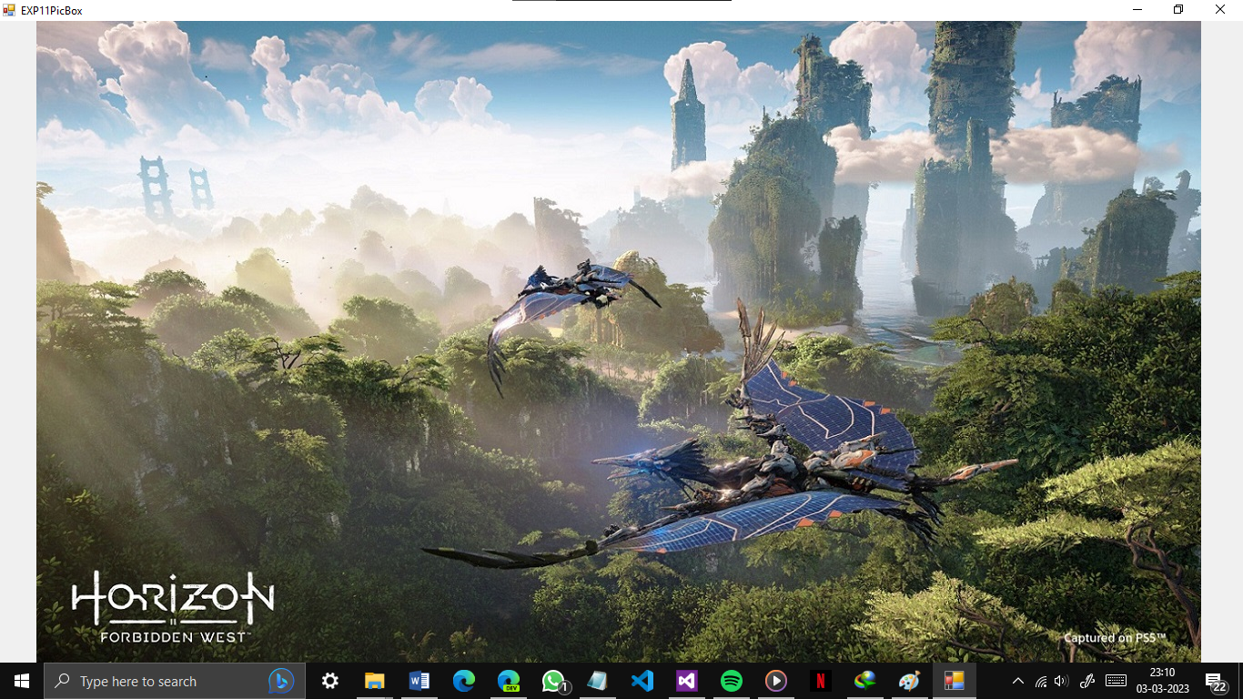

1. **Adding and using Panels**

**CODE:**

Public Class Form1

Private Sub Form1_Load(sender As Object, e As EventArgs) Handles MyBase.Load

Me.Text = "EXP11PanelUse"

End Sub

Private Sub Button1_Click(sender As Object, e As EventArgs) Handles Button1.Click

If Panel1.Visible = True Then

Panel1.Visible = False

'Panel2.Visible = False

Else

Panel1.Visible = True

'Panel2.Visible = False

End If

End Sub

Private Sub Button2_Click(sender As Object, e As EventArgs) Handles Button2.Click

If Panel2.Visible = True Then

'Panel1.Visible = False

Panel2.Visible = False

Else

'Panel1.Visible = False

Panel2.Visible = True

End If

End Sub

End Class

**OUTPUT:**

